# Similar designs for TopShooter

For team TopShooter we have opted to design a top down last man standing shooter game that will focus on players (5 per match) battling against each other until there is only one player left, this is further detailed in the brief provided by the group. In researching a functional game, the team decided to also research games that share similar design aspects so as to draw inspiration and help in the overall build of the project. The following will contain a list of games and the features that they each have that will be used in a similar fashion in TopShooter.

# Physical Design Aesthetic:

## Hotline Miami:

In Hotline Miami the gameplay is somewhat simplistic in the manner that the player navigates a building in a top-down perspective. The goal of the game is to clear all opponents from each floor as quickly as possible.

The way in which TopShooter will draw from this game is that of the physical looks and initial gameplay design. TopShooter will feature a much cleaner, less cluttered and simplistic design while featuring similar gameplay in that the players will need to clear all the other players from the stage before they can be declared the winner. Hotline Miami also plays with corridors and rooms in which enemies may have advantages of cover, the TopShooter team also hope to implement a similar functionality to the finished product so as to make the game more competitive.

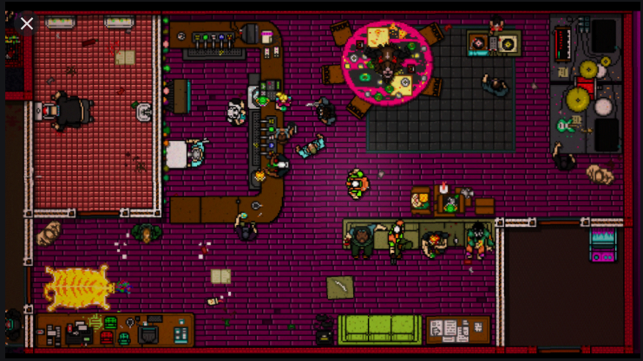

# Gameplay:

## PlayerUnknown Battlegrounds/Fortnite/Other Battle Royale:

Battle Royale games such as PUBG and Fortnite have increased in popularity in recent years and the TopShooter team have opted to draw on the competitive aspect that these games have been centred on. The idea that there can be only one winner works well with a simplistic design that our game is aiming for. Rather than using respawn and a points system like many other top down shooter games (such as Hotline Miami) we will opt for the simple method of when a player is killed they are eliminated from the match and will need to wait for the next match after the winner is eventually decided between the 5 in game players.

# References:

<https://www.google.com/search?q=hotline+miami&rlz=1C1CHBF_en-GBGB813GB813&sxsrf=ALeKk00GfitQdOjMM3j1ZxLQMVGxBg8SSg:1601385095340&source=lnms&tbm=isch&sa=X&ved=2ahUKEwjR-4WuuI7sAhVkShUIHYGrCrwQ_AUoAXoECCIQAw&biw=1536&bih=722#imgrc=hoEZddOPONJ1qM>